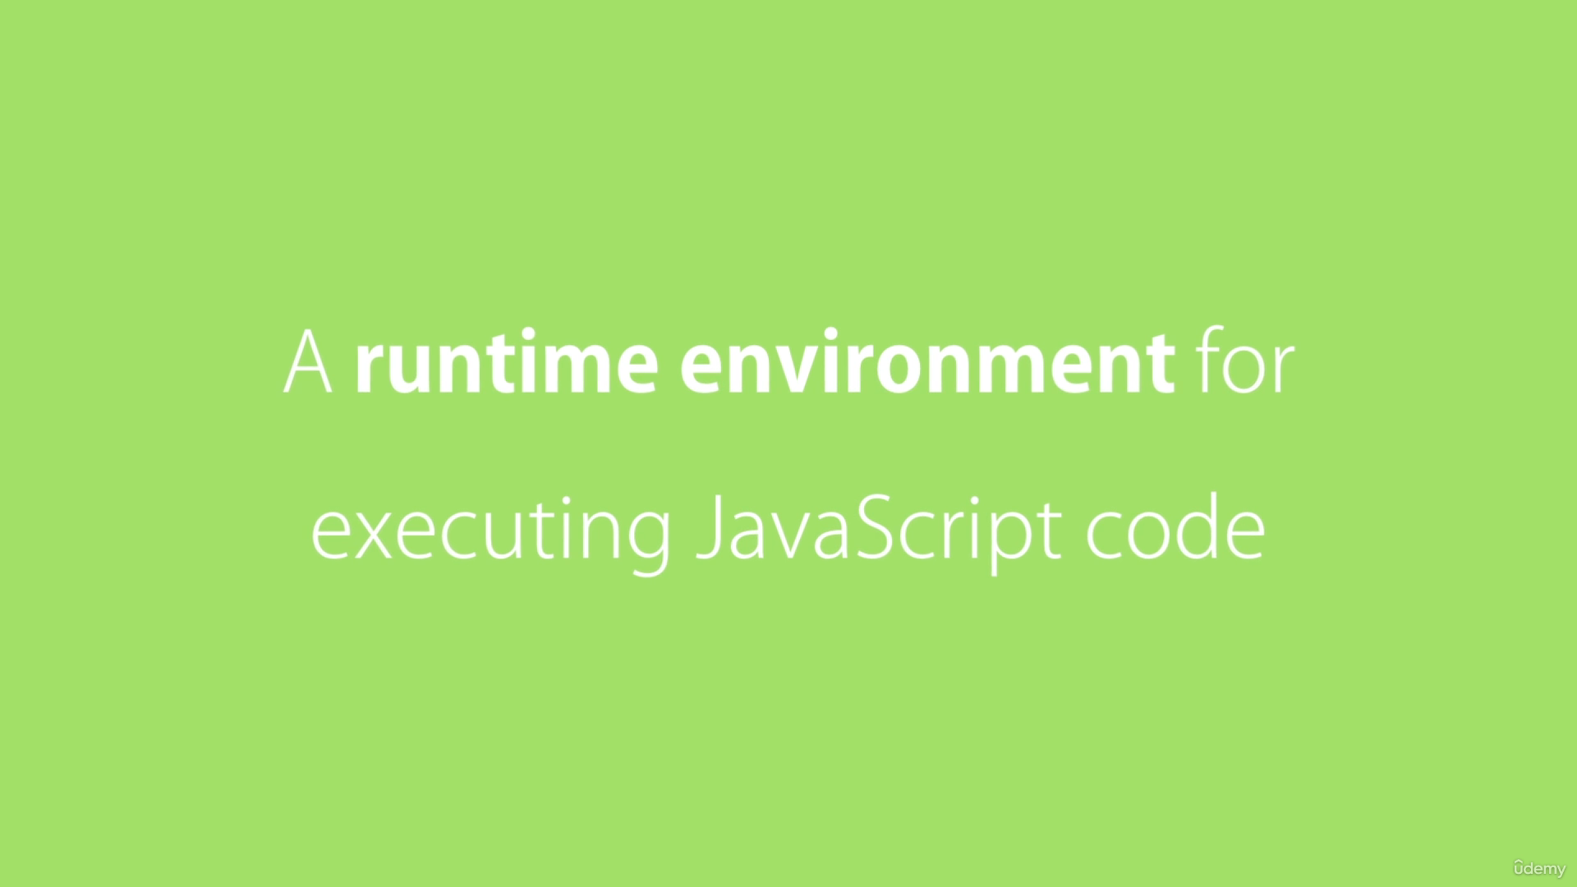

Node is open source and cross platform runtime environment for executing JavaScript code outside the browser.

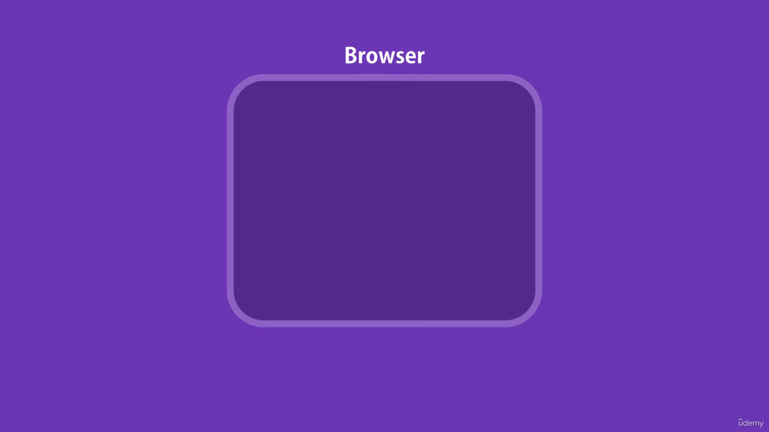

Prior to node, JavaScript was used to make applications that could run only in browsers.

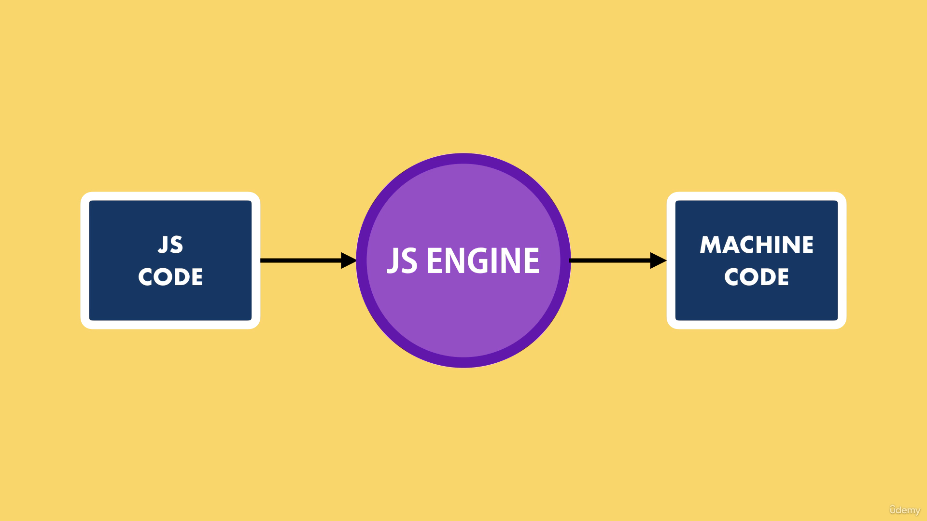

Every browser has the JavaScript engine that takes the JavaScript code and converts it into the code that computer can understand.

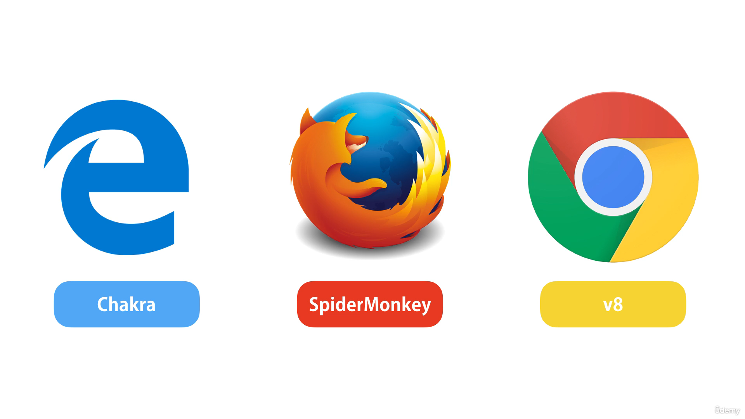

Microsoft edges uses the chakra, Firefox uses the SpiderMonkey and chrome use the V8 JavaScript Engine.

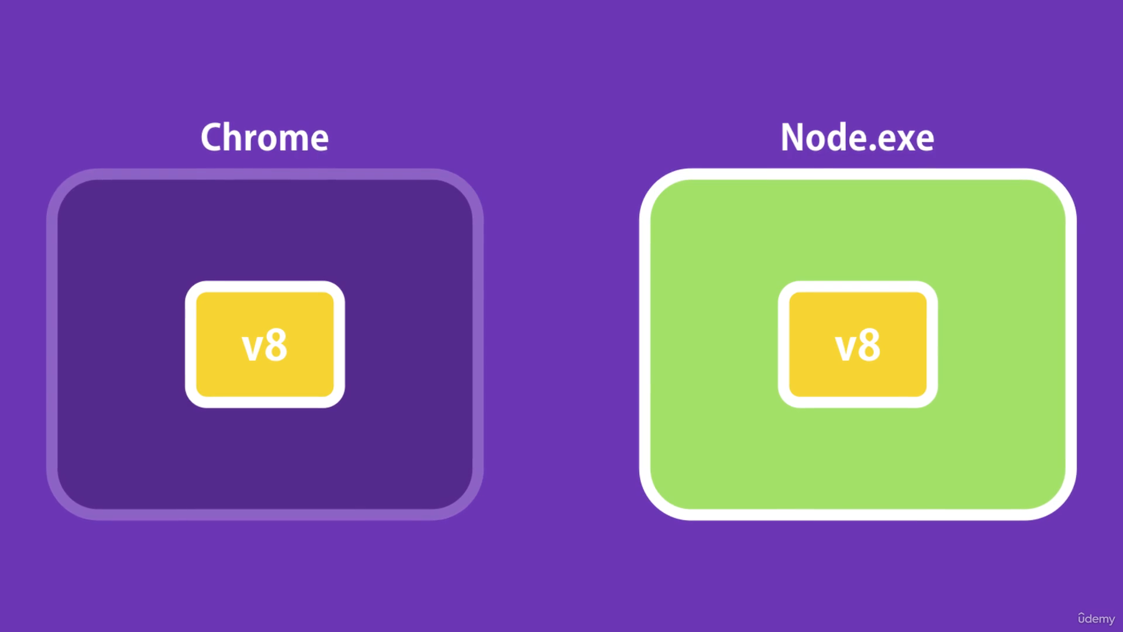



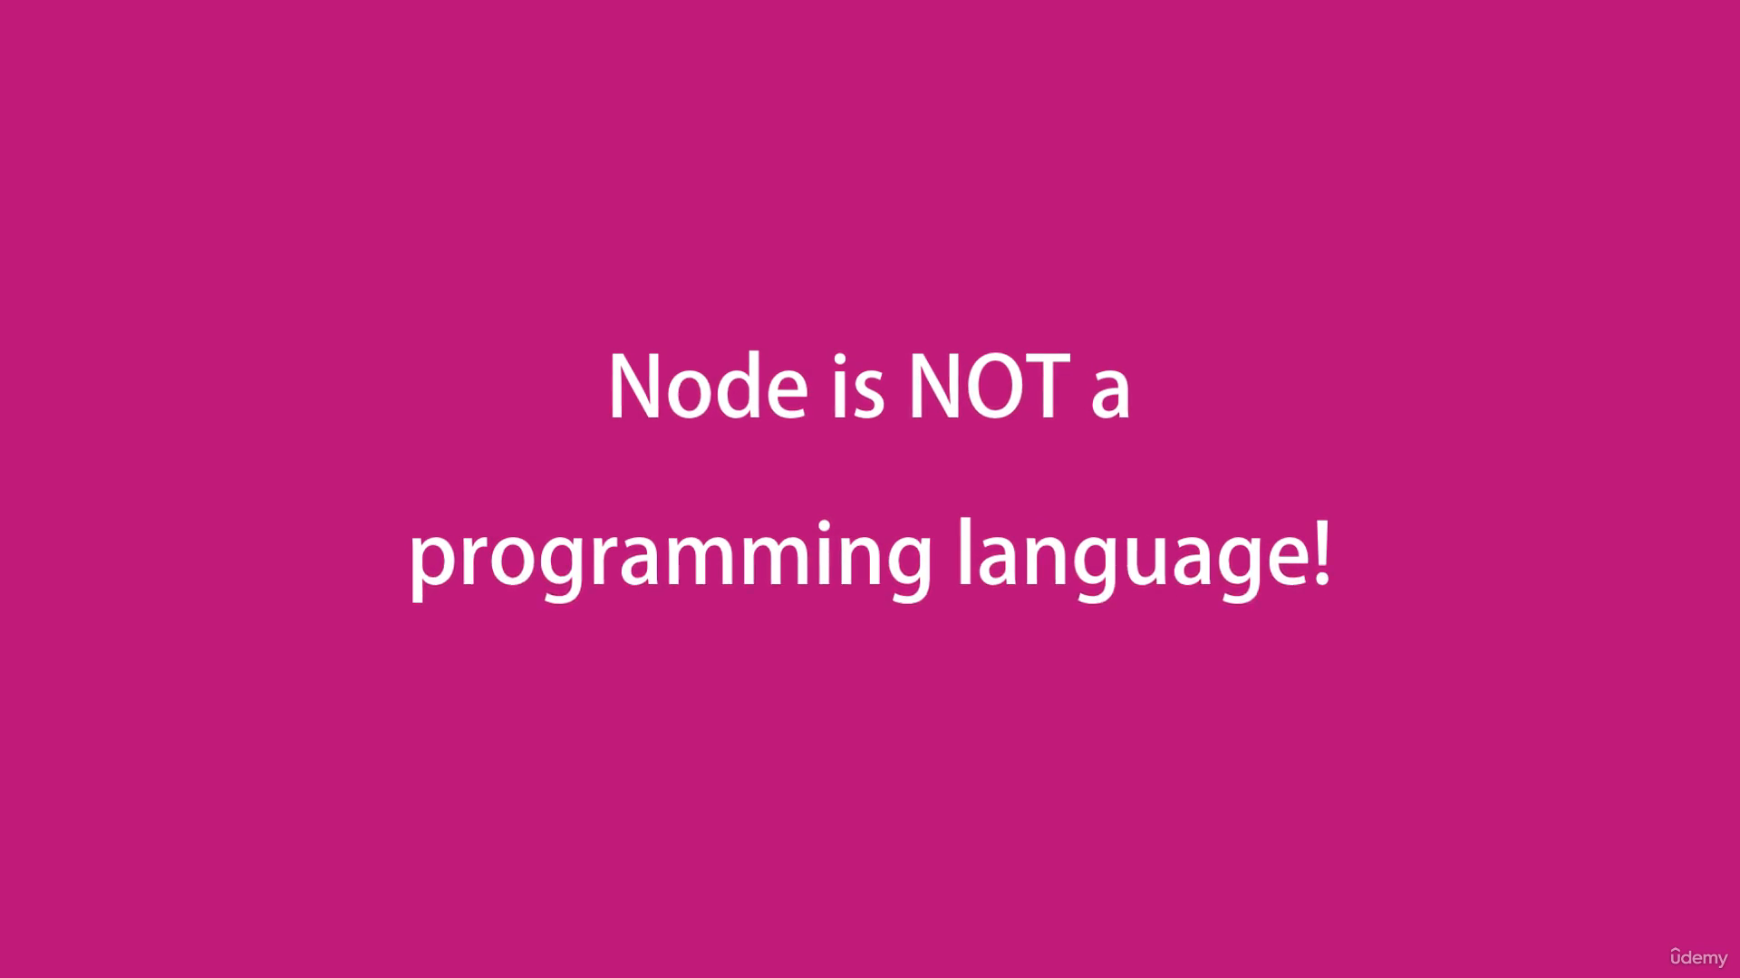

Node is not a programming language so, we can not compare node with any programming languages like C#, Ruby, etc.

Node is also not a framework so, we can not compare node with any frameworks like ASP.NET, DJANGO, RAILS etc.